Lab 4: Capture/Analyse Remote Communication Process
Mark: 20

What you will do:
• Using the skills and knowledge acquired in previous labs, you will build, configure, and test a Wired (Ethernet) network consisting of four nodes: two end devices (laptop) and two intermediary devices (Linksys router).
• Connect to a Web server.
• Capture and analyze the remote communication process where the sender and receiver are on different network segments.
• Implement basic router configuration: Connect to the router’s management web page
- Configure a static IP on the Internet interface (WAN-Linksys router)
- Modify the router’s IP address.
- Disable Network Address Translation (NAT)
- Allow anonymous Internet requests.

Things that you will need to know or learn:
• Identify and understand the different addressing layers necessary for successful communication.
• Understand the remote communication process.
• The general purpose and format of an ARP message.
• Writing simple Wireshark expressions to filter frames
• Understand the information provided in the Wireshark Details Pane to extract addressing information and map protocols to their OSI or TCP/IP network model layers.
• Connecting to a web server.
• Determining your network adapter’s MAC address.
• Determining your default gateway’s IP and MAC address.

What you need to submit and when:
• Complete the lab in class and demo it to your lab instructor.

Required Equipment: per team:
A partner
Two laptops
Two Linksys routers
Network cables: three crossovers
Webserver.exe downloaded to your computer (download folder)
Wireshark installed and working on both laptops

Layer 3 and 2 Addresses
Here are some useful rules to remember about addresses:
- A message’s layer 3 (IP address 192.168.1.4) and layer 4 port number (application port) values do not change as the message moves from one network to another.

- The message’s layer 2 (MAC address 45-de-e4-ae-34-f2) address values change as the message moves from one network to another. Here are the Layer 2 address values as the frame leaves the sender’s device:
When sending a message to a local device the frame’s destination MAC corresponds to the local device’s MAC address.
When sending a message to a remote device, the frame’s destination MAC corresponds to your default gateway’s MAC address.

Frames are the PDUs we place on the physical media. They are responsible for carrying our messages from one device to another within the boundaries of the same (local) network segment. If the device we wish to communicate with is on another network segment (remote network), then, the frame will be addressed and delivered to the default gateway. It is the default gateway (i.e. router) that performs the complex work of moving the message across the network.
Remember that a frame has no life beyond the (local) network segment on which it was created! The router discards the original frame and encapsulates a message in a new frame when it needs to move the message to another network.

Address Resolution Protocol (ARP) Local device
The ARP protocol operates on Wi-Fi and Ethernet networks and provides the mechanism for obtaining the layer 2 addresses necessary to move frames from one device to another within the same network segment. In short, the purpose of the ARP protocol is to resolve IPv4 addresses to MAC addresses.
Here is a brief and simplified description of how ARP works.
• When sending a message to a local device: An ARP request seeking to obtain the local device MAC address is broadcast (ff-ff-ff-ff-ff-ff) to all devices on the network segment as the sender The ARP request is of the form: • Who has a.b.c.d? Tell w.x.y.z
The ARP response is of the form: • w.x.y.z is at aa:bb:cc:dd:ee:ff (Mac)
The learned MAC address is used to direct the frame to its destination device. The learned MAC address is cached in the sending device’s local ARP memory.

Remote device:
When sending a message to a remote device: Remember that you direct all remote communications to your router (Default Gateway).
An ARP request seeking to obtain your default gateway’s MAC address is broadcast to all devices on the network segment.
The learned MAC address is used to direct the frame to your default gateway device. The default gateway does all the hard work involved in internetwork communications.
The learned MAC address is cached in the sending device’s local ARP memory.

Note that an ARP broadcast message does not exist/live beyond the network segment it was created on. That is a router will STOP the spread of an ARP message to other networks! Imagine the traffic that would exist if routers allowed ARPs to spread to all networks!
The arp –a command allows you to display the ARP table and hence determine the MAC address of devices your device has communicated with (locally). An ARP table ONLY contains MAC entries of other locally connected devices. You will never see or know the MAC address of a remote device – the only MAC you need to know to communicate with remote devices is the default gateway’s MAC address. Note that the entries in an ARP table have a time limit; (5 minutes) they will be deleted from memory after a configurable amount of time!

The figure below shows the output of running ipconfig and arp –a on a device having IP address 192.168.15.106. By examining the output below, we can tell that the default gateway’s MAC address for 192.168.15.106 is: 0c-47-3d-a1-88-82. We can deduct this information by first determining the Default Gateway address from the ipconfig output. We then take this IPv4 address and attempt to find a matching entry in the arp –a output. As there is an entry in the arp –a output for 192.168.15.1, its MAC address is the value that appears under the Physical Address column!

From the output, we cannot tell what the MAC address for 192.168.15.106 is. In this case, we would need to run ipconfig/all to obtain the MAC address for 192.168.15.106.
Note that the output below shows multiple interfaces, but as we have learned in class, the interface that provides connectivity with the outside world in this specific configuration is the Ethernet adapter.

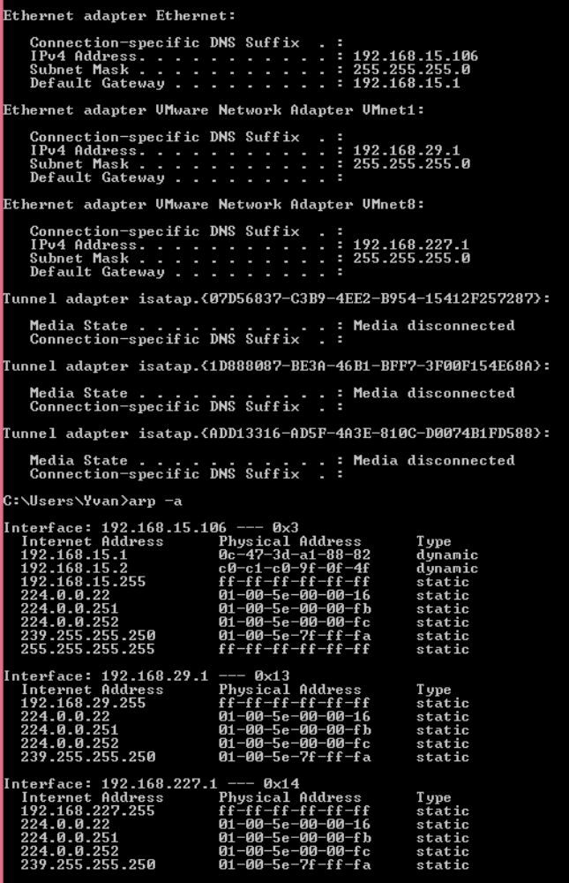

Task 0: Preparations
1 Find a partner to work with.
2 Run on one laptop: Webserver.exe – to install the Web Server
3 Lab04-router1-config – router 1 configuration instructions
4 Lab04-router2-config – router 2 configuration instructions
5 Disable all your network adapters and anti-virus and Windows Defender firewall. Your only connection to the network must be via the Ethernet (wired) interface.
6 Do not start until you have completed ALL steps in this task.

Task 1: Build, Configure, and Test Network
In this task, you will build, configure, and verify the proper operation of the network topology shown in “Lab 04 – Network Topology”. The network you are building consists of three separate network segments: Network Segment 1, Network Segment 2, and Network Segment 3.
Do not start Task 1 until you have completed all Task 0 steps. Remember you are working in teams of two.
1-reset your router.

Linksys dynamic IP address

2-Connect your laptop to any of your Linksys switch ports (1,2,3,4) using the appropriate cable
a. One laptop per router!
What cable did you use to connect your laptop to the router? CROSS-OVER

3. Connect the two routers via their respective Internet ports (yellow port-WAN) using the appropriate cable
What cable did you use to connect the two routers? STRAIGHT-THROUGH CABLE

DHCP (router) should provide you with an IP address (Dynamic), subnet Mask and Default Gateway number. (answer in RED) (6 mark)

Router 1: (you) Router 2 (partner)
IP address? 192.168.20.141 IP address? 192.168.10.147

SM? 255.255.255.0 SM? 255.255.255.0

DG? 192.168.20.1 DG? 192.168.10.1

4. Ping your router DG (192,168,10.1) or (192.168.20.1) At this time, you should get four TTL responses. (1 mark)
Ping Screenshot here
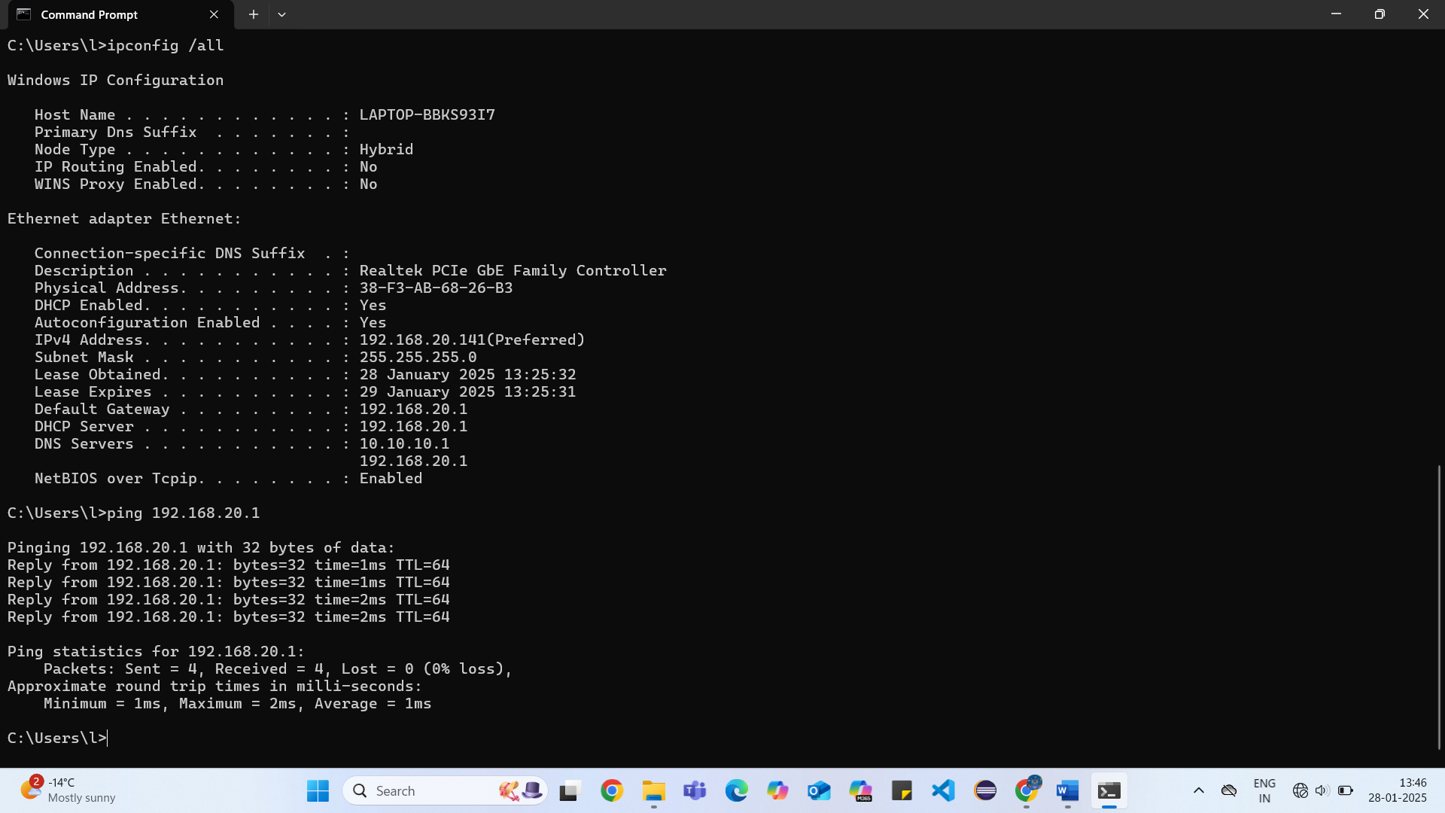

Linksys router static IP address:
1. Perform the router configuration (static IP address) as per the router configuration document:
a. Go to Lab04-router1-config document if you are router 1 and follow the instructions. Write IP, SM, and DG from your router1 document into your router.

b. Go to Lab04-router2-config document if you are router 2 and follow the instructions. Write IP, SM, and DG from your router2 document into your router.

Router1: you Router2: partner
IP address: 10.10.10.1 IP address: 10.10.10.2

SM: 255.255.255.252 SM: 255.255.255.0

MAC address? C0:C1:C0:BC:67:2D MAC address? B4:75:0E:AF:FD:EC

2. Do not continue until all local and remote connectivity (ping) tests have succeeded!
3. Record your addresses on your paper

Linksys network Topology:
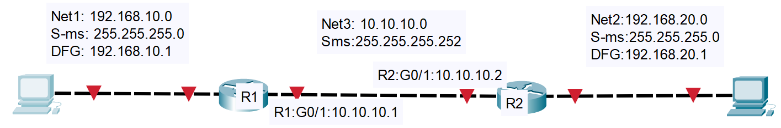

Task 2: Install and Test the Web Server
In this task, you are preparing the web server for task 3.
1. Assign a single laptop to be the web server. On that laptop only install and test the Web Server. Type in the following in the web browser’s address bar:
http:// web server’s IP address:8088
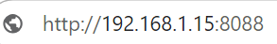

Note: the combination of IP address + port number (8088) is called a socket

2. DO not proceed unless you see client and server IP addresses. Example:
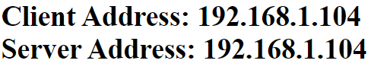

Task 3: Remote Communication Process
In this task, you will capture the http traffic between a web client and a web server. You are essentially repeating the same task as in the previous lab, except that the client and server devices are on different (remote) network segments.

1. On the client's laptop, open a web browser. Enter the following URL in the browser’s (Chrome, Firefox) address bar: http://server IP:8088
You should see client/server IP addresses. Example:

Note: if you don’t see these IP addresses, on the client web page, check the Document path on the webserver page. Make sure to see the webserver path.
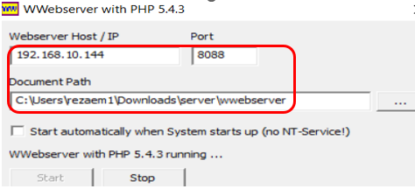
Example:

Do not proceed to the next step until the web page successfully displays in the web browser.

2-Start a Wireshark capture on both the web server and web client.
3. client laptop, open your web browser and type the server’s IP address with the server’s port number http://192.168.10.120:8088
4. Stop and filter WS capture by HTTP. Save your capture on both the client and server. Save as WS-task3.
5. On client and server, locate two captured frames having the following characteristics:

Client Request
GET / HTTP/1.1 in the info column.
where w.x.y.z in the source column (client IP)
a.b.c.d in the destination column (server IP)

Server Response
HTTP/1.1 304 Not modified OR
HTTP/1.1 200 OK in the info column
where w.x.y.z in the destination column (client IP)
a.b.c.d in the source column (server IP)

6. Here is an expression that filters the frame meeting the Client Request requirements in 5:
a. http && ip.dst==a.b.c.d && ip.src==w.x.y.z

Where a.b.c.d is the web server's IP address w.x.y.z is the client’s IP address.
b. Apply the filter and take a screen capture of the results. Your screen capture must include both Wireshark’s summary and details pane. (1 mark)

Screenshot here

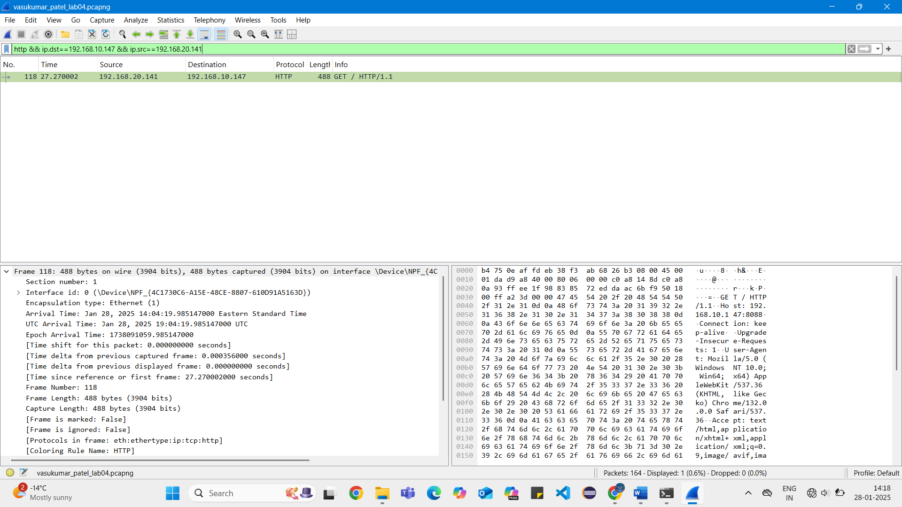

c. Compare the layer 4 and layer 3 address values with your partner’s. They MUST match. (Tip: Click on Ethernet II)
d. Save the screen capture.
7. - Compare the layer 2 address values with your partner’s values and answer the following questions. (4 Marks)

a. Are they identical or different? Different
b. Answer the following questions if you answered Differently in 7

a: Explain why they do not match.
BECAUSE THE NETWORK CHANGED.

The destination MAC corresponds to which device?
WITH END DEVICE

The source MAC corresponds to which device?
WITH ROUTER

8. Examine your laptop’s ARP table
a. From a Command Prompt type: arp –a
b. The command shows the IP to MAC mappings that have been learned by your laptop.

You want to focus on the entries that fall under the Interface bearing the IP address assigned to your Ethernet adapter.
c. Do you see any entries for your partner’s IP or MAC? (1mark)
Yes

Which entry served to communicate with your partner’s laptop? Screen capture the arp –an output and highlight the entry that is used for remote communication. (1 mark)

Screenshot here
